J.C. and I-MAG Join Forces for an Evening of Enlightenment

The Journalistic Club (JC) in The National Union of Kuwait Students in cooperation with I-MAG Magazine is organising "an evening of enlightenment" on Wednesday.

The evening's aim is to present an even-handed image about the Prophet of Islam Muhammad (PBUH). A documentary titled "Muhammad: Legacy of a Prophet" which was produced by the PBS will be screened during the evening. Furthermore, a premiere of Ahmad Alhajry's video clip (Muhammad P.B.U.H) with English subtitle will be screened to the audience.

The head of the Journalistic Club Sumaiya Almaimani said "the aim of the club is to help its participants acquire journalistic skills and ethics, and one major point in that is objectivity, and that's what we are trying to do in this evening' present an objective image of the Prophet (PBUH).

Hayat Alyaqout, the Editor-in-Chief of I-MAG Magazine which is a free non-profit electronic magazine said: "we are not trying to preach, we are not trying to convert non-Muslims into Muslims, what we are mainly interested in is enlightenment, people need to be educated about the life of this great man, people deserve to know him, before we blame them for slandering him as in what happened in Denmark and other European countries."

The event will take place on February 22nd, 2006 at 6:15 P.M. in Kuwait University, Khalidiyah Campus, NUKS Building, 20 KH, ground floor.

For more information email: info@I-MAG.org
Or visit the official website of the event where media kit is available: www.I-MAG.org/light



Hayat Alyaqout
Editor-in-Chief, I-MAG.org
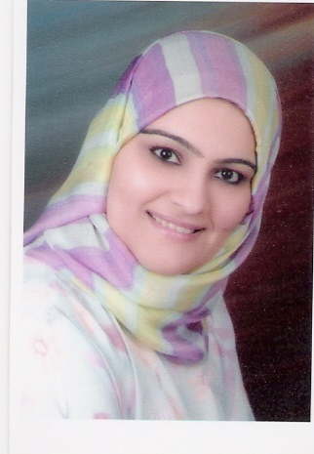
Sumaiya Almaimani
Journalistic Club, Head

